** **

**Project Initialization and Planning Phase**

| Date | 24 April 2024 |
| --- | --- |
| Team ID | 739744 |
| Project Name | Freedom of the World Classification |
| Maximum Marks | 3 Marks |

**Define Problem Statement:**

 Freedom of World Classification involves identifying and categorizing countries based on their levels of freedom, considering factors such as political rights, civil liberties, economic freedom, and social freedoms. Predictive analytics and machine learning techniques can be used to analyze large amounts of data to identify patterns and classify countries into different freedom levels..

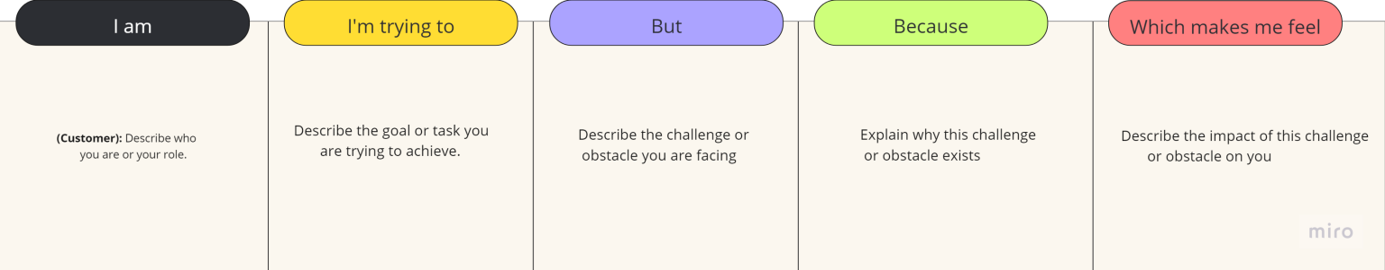

|  |  |  |  |  |  |
| --- | --- | --- | --- | --- | --- |
| **Problem**  **Statement (PS)** | **I am**  **(Customer)** | **I’m trying to** | **But** | **Because** | **Which makes me feel** |
| PS-1 | Describe who you are or your role. | Describe the goal or task you are trying to achieve | Describe the challenge or obstacle you are facing | Explain why this challenge or obstacle exists | Describe the impact of this challenge or obstacle |